Engineers Without Borders: Engineers without Borders (EWB) – MJCET student chapter has been established in the year 2002 in affiliation with EWB-USA and currently it is affiliated to EWB-India. Its mission is inspired by an urgent concern for accelerating sustainable rural development, assisting in capacity building in backward rural and urban communities of India, protecting the countrys natural resource base and working across national boundaries for social and economic justice and for responsible use of technology.

Faculty Coordinators : Dr. Ishrat Meera Mirzana,
Mrs NBV Lakshmi Kumari
Student Governing Body

Sno | Position | Name
1 | President | Mohammed Hyder Afnan
2 | Vice President | Atif Ahmed
3 | Secretary | Mohammed Abdul  Kalam
4 | Joint Secretary | Syed Abdul Quawi
5 | Treasurer | Mohammed  Riyazuddin

1.World Environment Day : June 5 ,2024

In view of the World Environment Day a online quiz was conducted, more than 100 students participated in the quiz. Plantation Drive was organized at Government School Erramanzil explanting the importance of Plantation. More than 25 students participated in the program.

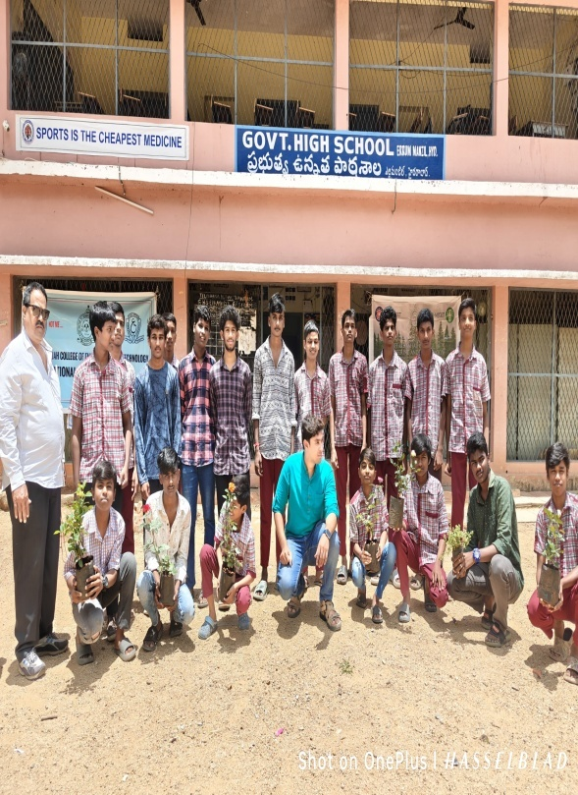


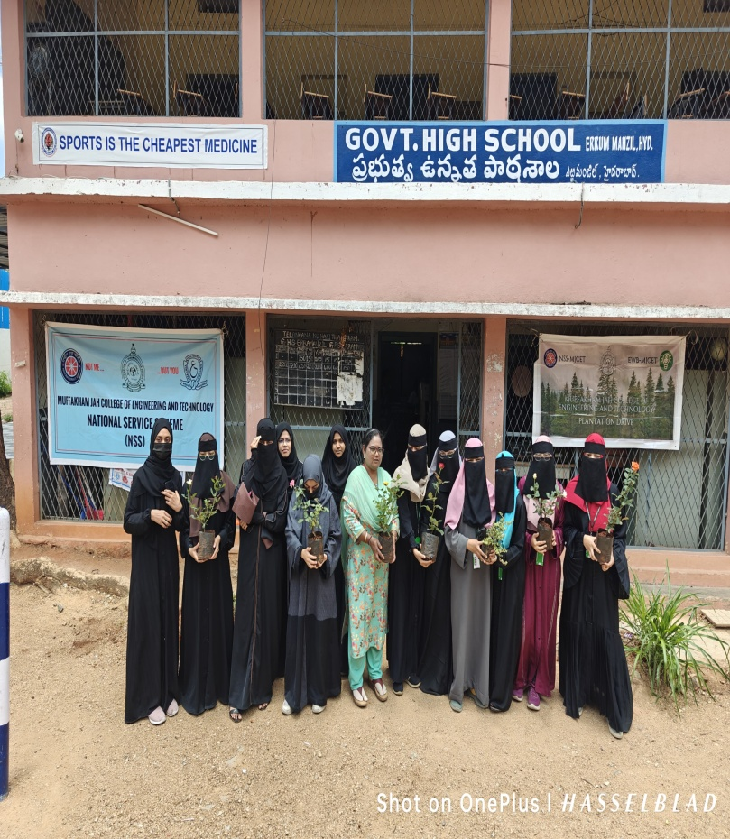

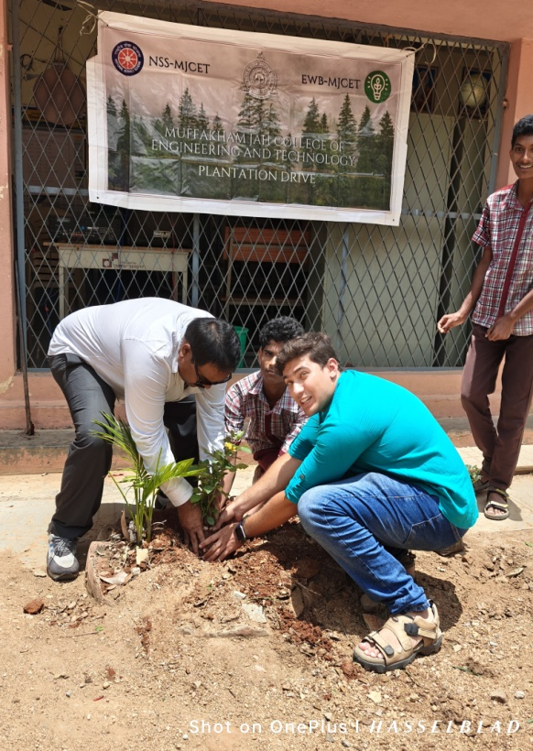
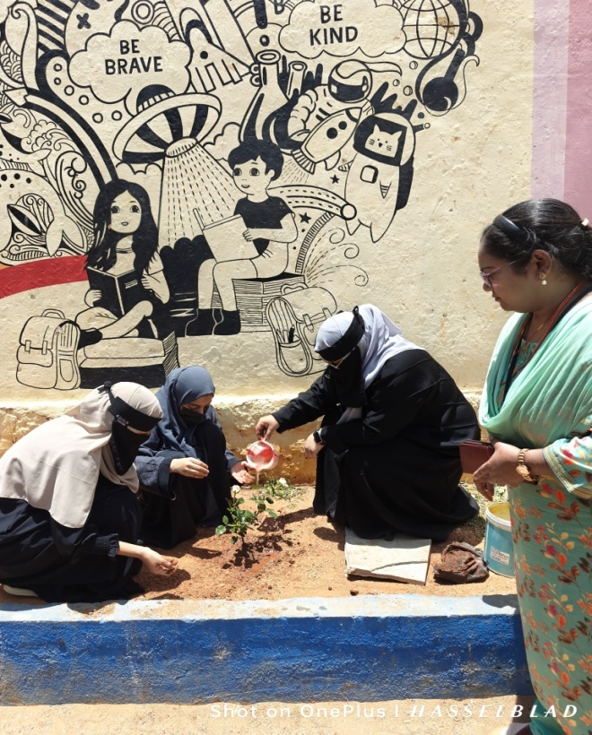

2. World Education Day Participation Report
Date: 24/01/2025 at HITAM College
The EWB-MJCET team actively participated in World Education Day organized at HITAM College. Representing the college, EWB President Mohd Hyder Ali Afnan and Sohel showcased the E-Learning Centers Project, which aimed at promoting digital education access for underprivileged communities.
The project presentation was well-received and highlighted innovative solutions to bridge the digital divide in education. Out of several participants, the project was awarded the Second Prize, bringing recognition and pride to the EWB-MJCET chapter.
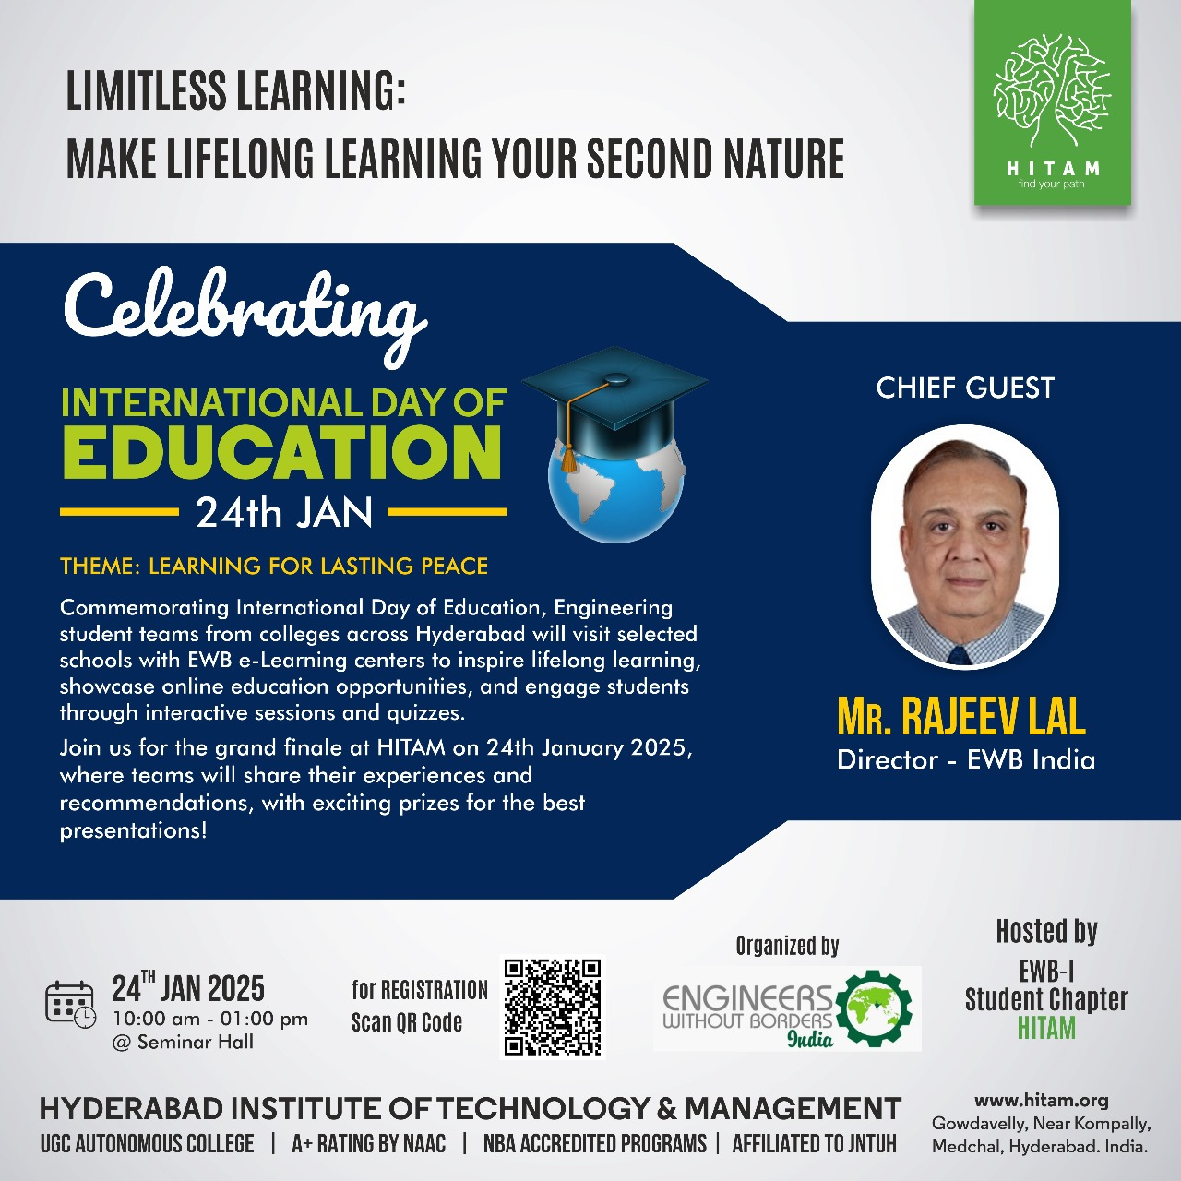
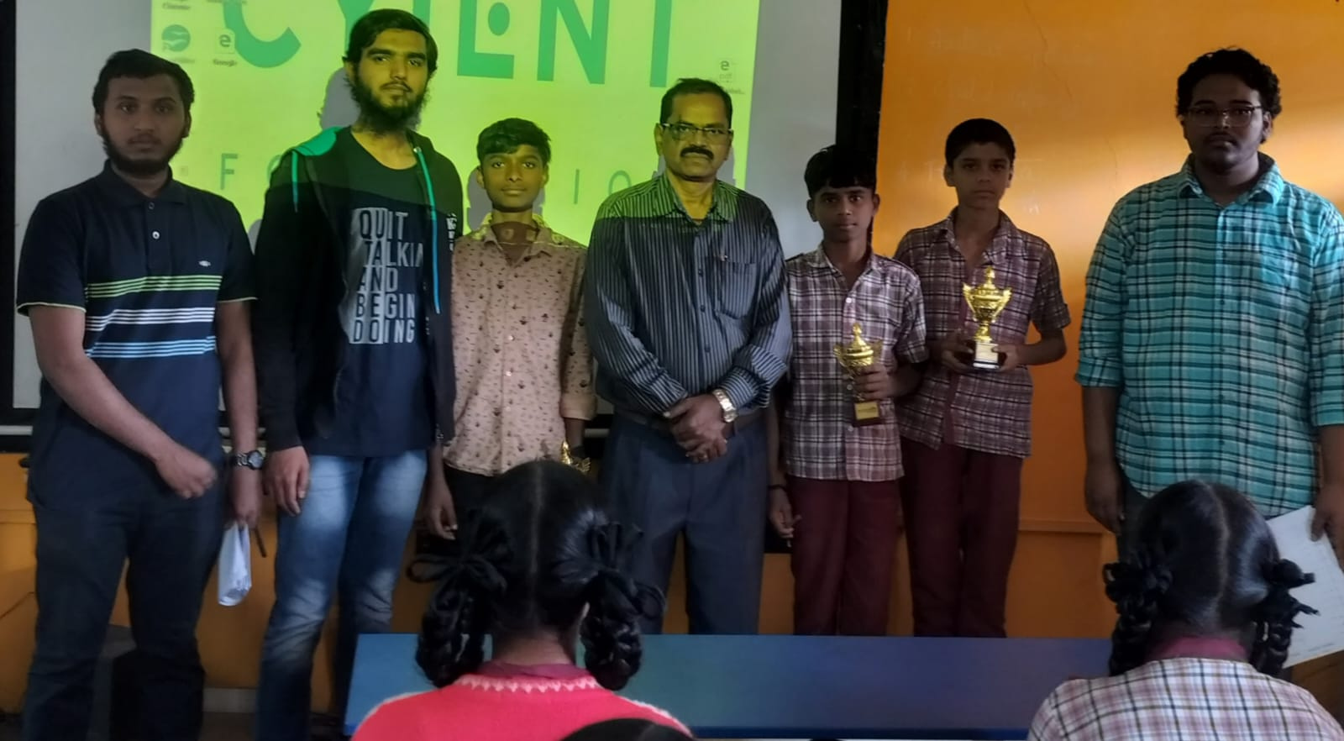
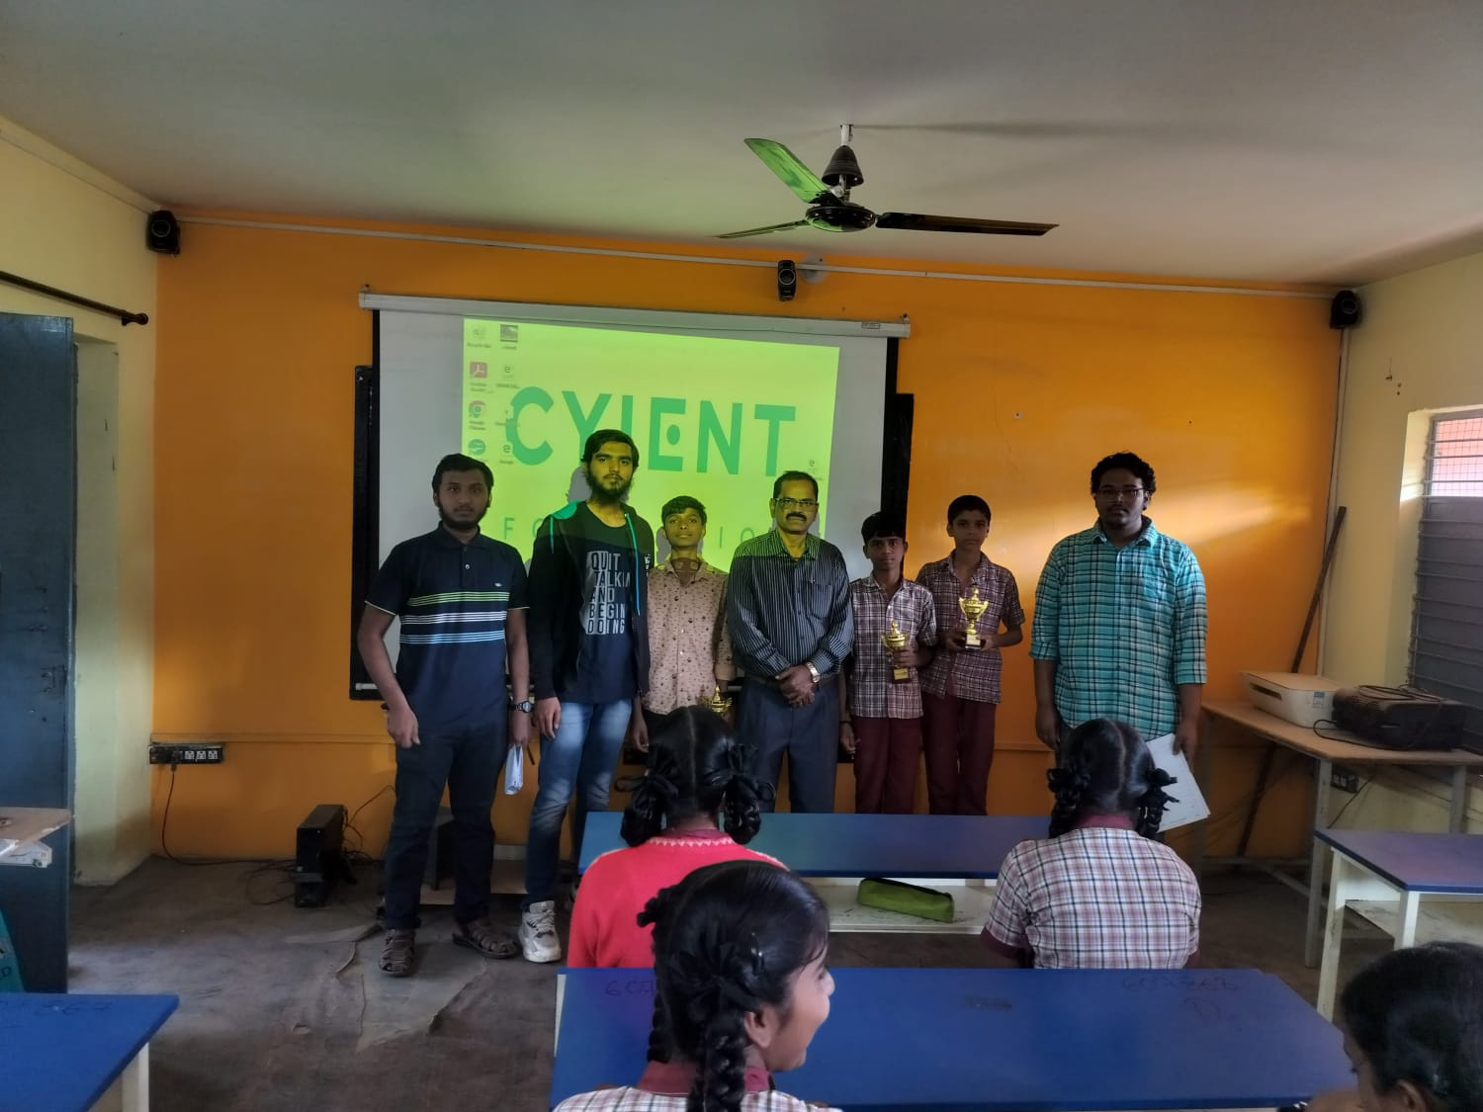
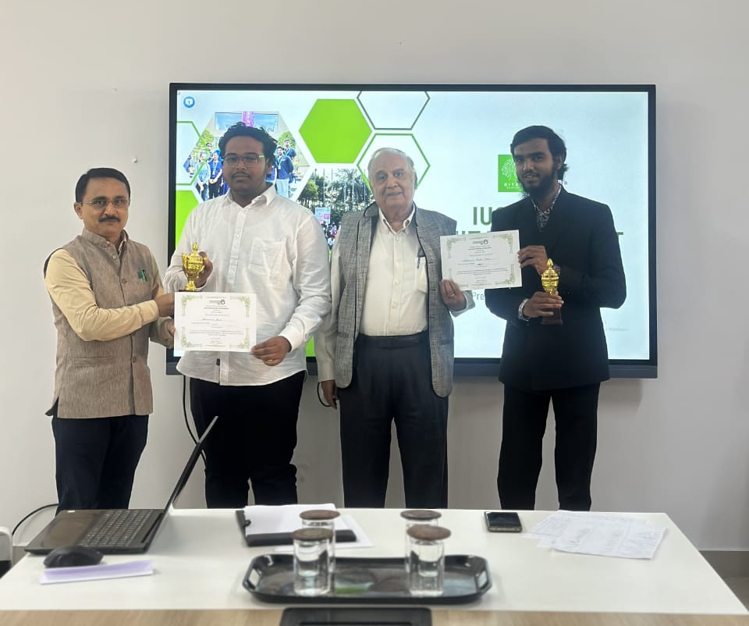

PROJECT’s

1.Name of the Project: KGNMT –Project in collaboration with EWB-MJCET & EWB-INDIA
Date of Visit: 28-08-2023
Brief Note about KGNMT
The KASTURBA GANDHI NATIONAL MEMORIAL TRUST was established in 1945 as a result of the national endeavor, led by Mahatma Gandhi, to address the issues of women in rural India. The unique history of the Kasturba Gandhi National Memorial Trust is set against the backdrop of the history of India's freedom struggle. Eminent people from all walks of life as well as the anonymous masses, mobilized their resources to set up this Trust with its headquarters in Kasturbagram (Indore) and 22 state branches all over the country.
Location: Kasturba Gandhi National Memorial Trust Hyder Shah Kote, Langar Houz, Hyderabad, BandlagudaJagir, Telangana 500091.

Team Members:
S.No | Name | Branch | Year | Email-Id | Phone No.
1 | Faizan Ahmed | Mechanical | 3 | faizanahmed1038@gmail.com | 9908359717
2 | Mohammed  Riyazuddin | Mechanical | 3 | uddinriyaz302@gmail.com | 9515791624
3 | Mohammed Abdul Kalam | Mechanical | 3 | abdulkalam428@gmail.com | 9642149573
4 | Syed Abdul Quawi | Mechanical | 3 | abdulqawi@gmail.com | 7842235912
5 | Khaja Moinuddin | Mechanical | 3 | khajamoinuddin9133@gmail.com | 8688701017
6 | Syed Faraz Hussain | Mechanical | 3 | farazhussain794@gmail.com | 7661887321
7 | Mohammed Saqib | Mechanical | 3 | 007saqibahmed@gmail.com | 9398687678
8 | Mohammed Hyder Afnan | Computer  Science | 1 | 160422733029@mjcollege.ac.in | 8639270945
9 | Atif Mohammed Khaleel | Computer  Science | 1 | Atifsaif2004@gmail.com | 7075821913
10 | Mohammed Fardeen Khan | Computer  Science | 1 | mfardeenkhan25@gmail.com | 9000529240
11 | Mohammed Abdullah Shareef | Computer  Science | 1 | abdullahshareef5026@gmail.com | 7780227803
12 | Akhil Khan

Objectives:
The purpose of the visit was to evaluate the underlying problems and issues faced at KGNMT Trust.

Findings from the Survey:
- High electricity bills due to maintenance charges for the batteries that store the solar energy.
- Inefficient networking of wires for flood lights.
- High Consumption of Fuel for cooking.
- Increased water consumption.

Statistics of KGMNT

S.No. | Description | Capacity | Consumption | Expenditure(Rupees )
1. | Electricity | 140 Members | 8,421units (approx.) | 50,000-60,000/-
2. | Food Staples (Rice) | 140 Members | 25Kg (Daily) | 30,000 /-
3. | Water Consumption | 140 Members | 2000L
4. | SolarPanels Maintenance-Batteries | 40 panels | 40 | 3,00,000/-(Per Year)
5. | Fuel Consumption | 140Members | 01 Cylinder (2 Days) | 2000/- (Per Cylinder)

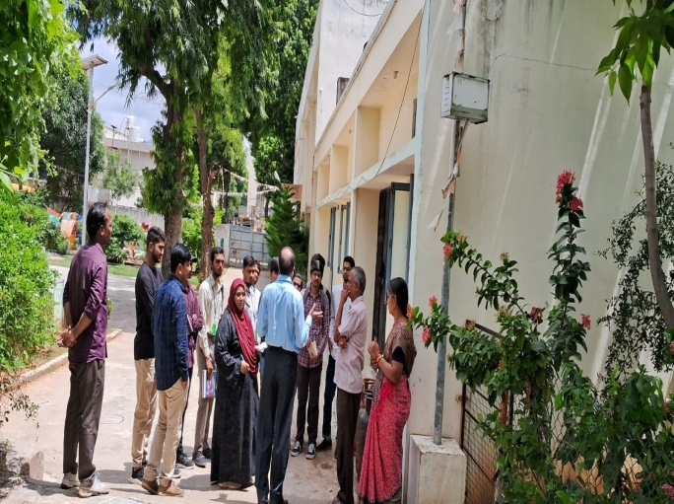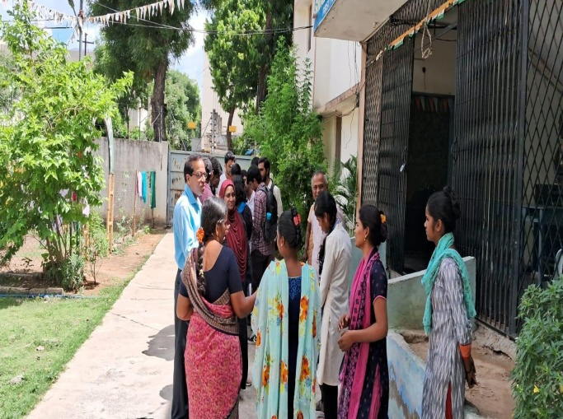

Interaction with the staff

.
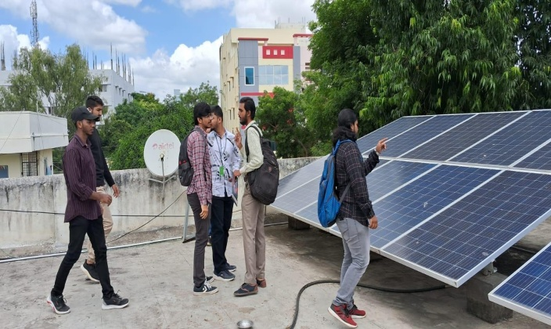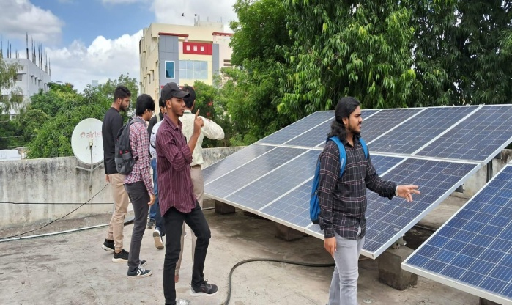

Analysis of the Solar Panels

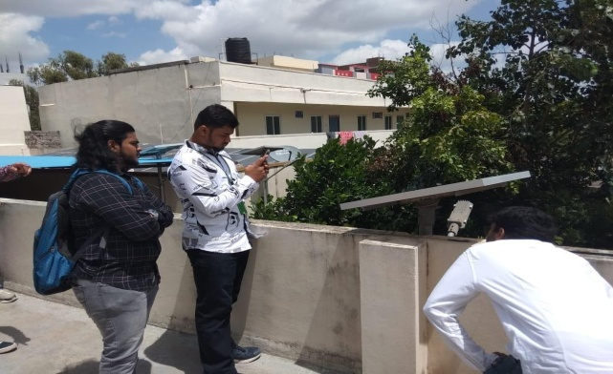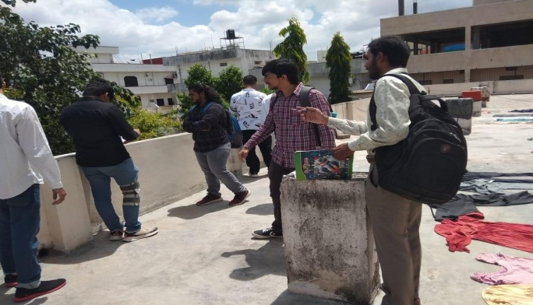

Observation of Solar Panel on Light Poles

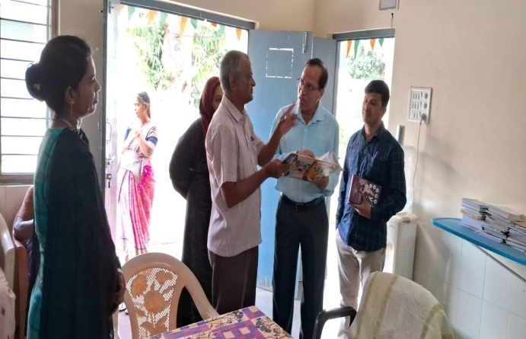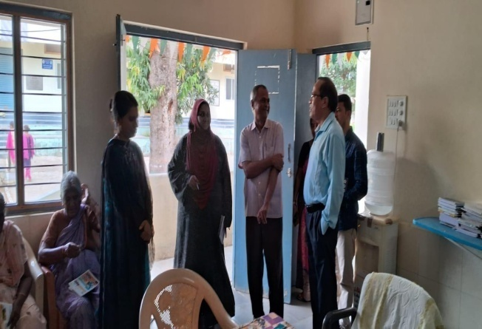

Discussion with Staff on Cooking Charges

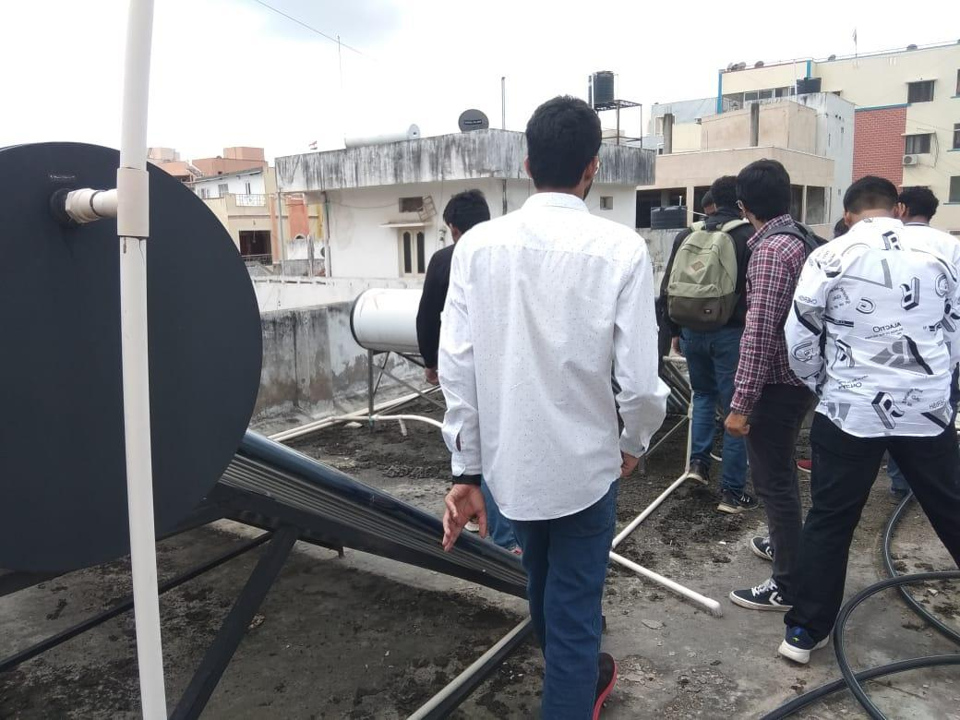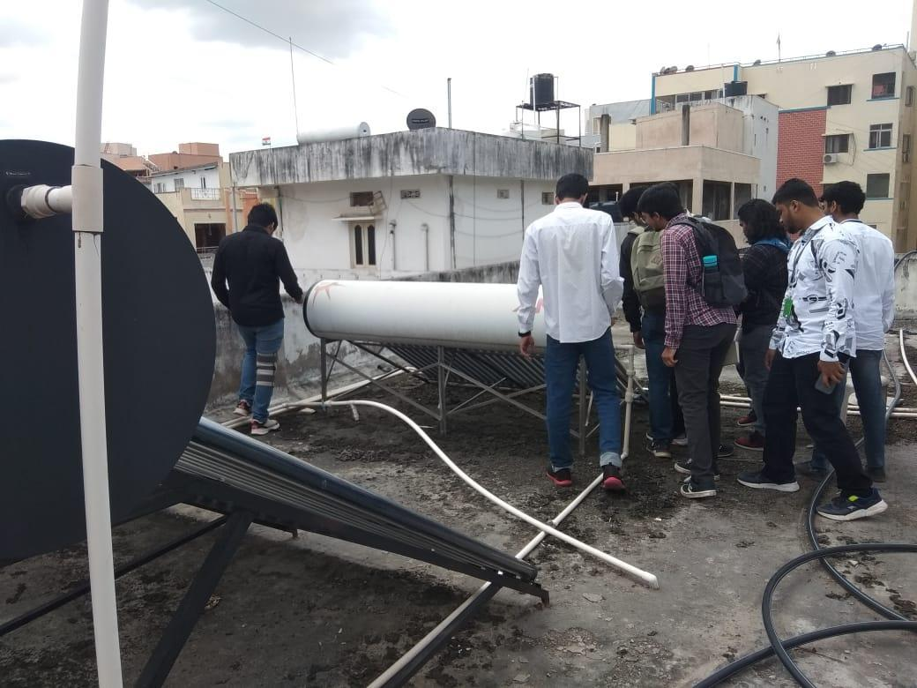
Examination of the Water Heating System

